How can India break into the top league in sports-?
An independent research project by an international level player-
Devanshi Rathi
Introduction-
India is a country which faces numerous shortcomings in the field of sports. This fact is made clear by the lack of a large number of Olympic Medals. Till date, India has won fewer medals in its entire Olympic history than a single swimmer Michael Phelps from the USA, who has won 25 international Olympic Medals. Our country has only one individual Olympic Gold Medalist- Abhinav Bindra, who won the gold for shooting in 2008. Since then our country has not produced even a single gold medalist. We have managed to win only two medals in the 2016 Rio Olympics going down from 5 medals in 2012. The country has a tremendous amount of untapped talent and if steps are not taken immediately, it would be extremely difficult to target even 10 medals in 2024. 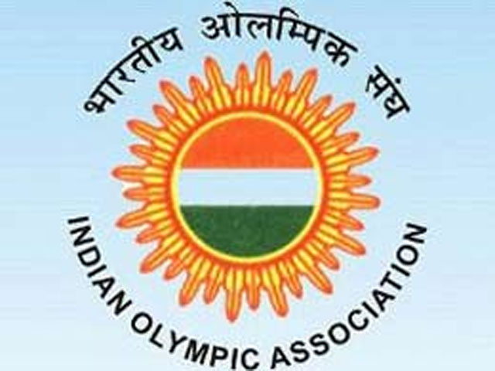

Challenges faced-
1. Lack of training facilities like grounds, gyms, health care centres, wellness centres, swimming pools, badminton courts, squash courts, tennis courts, and other sporting facilities.
2. Serious lack of world class coaches, trained by international institutions. Investment in coaches is extremely inefficient.
3. Improper sanitation facilities for players like unhealthy food, dirty toilets, no proper drinking water.
4. Lack of a proper training mechanism for world class players and potential players.
5. Lack of corporate sponsors for players and coaches.
6. Lack of world class tournaments and other domestic tournaments.
7. Gender bias in the sports arena. Girls are not given equal pay or importance.
8. No proper training kits and no utilization of world class equipment. Players do not have access to world class training techniques like analysis, motivational training, mind training, video recorded footage, instructional videos, coaching camps with famous players, strength training.
9. No promotional activities in schools and colleges. Students are not encouraged enough to take up sports as a career.
10. Not enough mentorship for athletes participating in big events like the Olympics, Asian Games, World Championships, and Commonwealth Games and Championships.
11. Limited prize money for domestic tournaments. No funding for world class level tournaments.

Impacts-
There are various impacts of the lack of attention towards sports. Some of them are-
- No Medals at the Olympic Games. Only a very few no. of medals if any at all.
- No Promotion of Sports. Less physical activity for the population. More people want to take up a career in the fields of education, media and communication, healthcare, business, etc. Professional Sports are limited.
- Gender inequality is rampant. Girls are faced with various problems when they decide to take up a career in sport. They are not encouraged and do not get any incentives.
- Lack of experience at the professional level.
- Population’s fitness levels are on the decline and cannot be rectified easily.
- Migration of super talents to foreign countries due to lack of exposure.
- Paltry means of living for state and national level players. These players do not get enough funding to grow to their highest potential.
Solutions-
One of the main challenges faced by Indians is the infrastructure facilities to play sports. This is the main reason why we are not able to compete with strong sporting nations like the USA and China. The IOA has to take up several ventures to promote sports in India. Some of these could be the following-
- Following Indian women’s historic medals at the Rio Olympics, more training should be provided to women players. They should be given an equal chance to compete and given equal amount of prize share as men. Take the case of National Championships Most strong players avoid these as they do not offer adequate prize money. So, there should be an increase in the prize fund of these championships to attract more women players. Women should also be playing in special tournaments organized for them by the IOA. There should be training camps sponsored by the IOA permitting the trainee to bring along her coach.IOA should only aim to provide the facilities not the trainer as each trainee has his/her own likes and dislikes and training method.

- The IOA should aim to develop grassroots programs in schools and colleges, where exceptional talent should be spotted and given a chance to flourish. These trainees should be invited to train at specific IOA centres and given tournament expenses etc.

- The IOA should look to organize more international level events. These could be the already prevailing league systems in India. However, these league systems should have a domestic version also. The domestic players who are not known should also be given a fair chance.

- The IOA should aim to create sports centres in different places across the country. These centres should be equipped with gyms, spas, swimming pools, rehab centres, educational learning(for younger players) which will help players get their degree without much compromise, pro shop for all the latest equipment, virtual training system(players games’ are recorded for view later), and the specific requirements for each Olympic sport. Players must be encouraged to come and practice here with half the cost payable by the IOA. Olympic medalists should be provided with free training facilities.

- Coaches should be mentored. There should be funds allocated for their development as they play a huge role in the players’ futures.

- The stadiums in different cities should be well maintained as the players do not get a proper training schedule then.

- More tournaments should be organized for the players to get a fair chance of competing with the international pool of players. Specialized training camps in international countries should be organized for talented players and coaches. There can be exchange programs for youngsters. Youngsters should also be getting a fair chance to compete against some stiff competition.

- IOA should try to bring in corporate sponsors, making use of the CSR Program and Make in India program. Sports equipment should be purchased for the players.

- IOA should adopt the talented players and provide them with specialized training along with their coaches. They should be given funds and corporate sponsors for their training.

- There can also be special talks and lectures by famous sports personalities for youngsters as this will help them groom themselves into better players.

- Special Olympic camps must be held every 4 months and closer to the games every month.

- IOA should make use of Government schemes for talented sportspersons and players to get funds.

- IOA should also make use of Govt. funds for infrastructure and sport.

- IOA can cut down costs of hiring their own trainers by simply using the trainee’s trainers when he/she comes to the IOA centre for development. The trainee should be responsible to bear the costs of the coach. This money saved can be used to further enhance the players’ facilities.

- National tournaments should be made compulsory.

- Specialized camps must be held in schools to make sports more popular.

Conclusion-
The idea for writing this paper was because I have witnessed these incidents and shortcomings myself in the field of sports in the country. Having played international level sport for the past ten years now, I haven’t seen any great improvement. Though there have been a few changes, there hasn’t been any major improvement in the level of sports in the country. It is extremely disappointing to note that only 2 Indians out of a population of over 7 billion people could win a medal at the Olympic Games. It is a shame on the country and if steps are not taken, it will get harder and harder to improve. The idea for change is not so difficult. It just needs to be implemented and executed properly. If we take the right steps NOW, only then can we achieve success at the 2020 Olympic Games and the games after that. We must set daily targets and go step by step to achieve success in this sphere.
We must all be positive and confident. We must believe in ourselves and in our coaches/trainers. We must continue to work hard and try to keep on improving each day. In the end, it is only the most resilient who turn out to be victorious.

Bibliography-(General)
- Experiences on the chess circuit
- Experiences of watching live sport matches and tournaments
- Experiences of interacting with several top level players
- Books of several Indian Sporting Legends
- Internet Interviews and Magazine Interviews

